MASSIMO PRESCIUTTI Drawing on the run!

exibition at Galeria Satyry Na Tynku of Tarnowskie Góry (Poland)
2010 September 9th

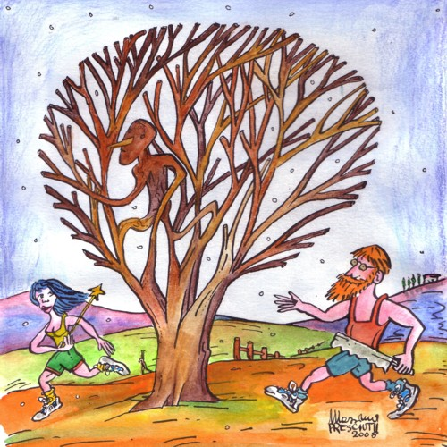

Massimo Presciutti is a training teacher, musician, poet, satirist and humorist. He started his artistic career in 1976 in Ca Balà, a political satire magazine tied to the youth movements of the sixty-eight following the wave of the European experiences like for example “Hara Kiri” in France, “Pardon” in Germany, “Hermano Lobo” in Spain or “Szpilki” in Poland. The main way of the “Ca Balà” humour was described like “scatologic” by the writer famous in the world Umberto Eco in 1974 (Presentation to the book about the military takeover by Allende in Chile called “I fumetti di Unitad Popular” - “The Unitad Popular comics” - , Celuc, Milano 1974). Massimo has had his drawings published in “L’Espresso”, “Panorama”, “Il Male”, “ABC”, “Help” “La Repubblica”, “l’Unità”, “Nebelspalter”, and others. He has exhibited his work both in Italy abroad, his drawings was filed by the Premio Satira of Forte dei Marmi City in union with the Italian and all the World’s drawers. In the early eighties he started a personal search about the music and drawing introduced in his work of teacher and training teacher, that’s his work since 1983. The Project where they are coordinated and harmonized literature, music and drawing is called “Musical Linguistic Laboratory” and since 1998 this experience was linked to the Socrates and Lifelong Learning Programmes.
The works of this show, Drawing on the run, they are taken from a electronic review (directed by his friend Indro Neri) about the run at amateur and professional level. Dedicated to the world of the running is also Via col tempo (“Gone with the time”), a free electronic comic books for kids featuring time travel adventures exploring the running activity in every period of History (in Italian). The last adventure of this series is about the old Thracian people (and it is directly related to the Comenius "Happy S.C.I.E.N.C.E." and to the Bulgaria, one among the partners of this Project shared by Italy, Romania and Poland (Zespół Szkolno-Przedszkolny nr 1 of Tarnowskie Góry, whose coordinator Ms Danuta Herman has conceived this exhibition together with the Headmaster Mr. Andrzej Sosna).
The choice of the drawings without words is because they can be appreciated outside the language barrier and they are addressed to the all ages people in harmony with the Lifelong Learning Programme. To tell the move is to tell the life and back: our foots are the prime mover on the space like our heart is the prime mover of the soul.
